[This page is for internal use only. Authors, please do not modify.]

FASR Science Use Case Template

Version 0.2

Template Change Record

Version | Date | Author | Affected Section(s) | Comments
0.1 | 08/21/2025 | B. Chen | All | First draft.
0.2 | 08/27/2025 | B. Chen | Sect. 3(A), 3(D) | Add linear polarization and image latency requirements

FASR Science Use Case # XX

Investigation of compact transient structures in the low corona

Surajit Mondal¹, Author 2², Author 3³…
¹New Jersey Institute of Technology
²Affiliation 2
³Affiliation 3
…

I. Science Goal(s)

The quiet Sun and coronal holes are believed to be the site of multitude of weak magnetic reconnections and particle acceleration. However, direct observations of the magnetic reconnection and particle acceleration at these locations remain elusive. With the excellent imaging fidelity and sensitivity expected from FASR, we aim to characterize the nonthermal emissions from these weak magnetic reconnections and thus answer questions about coronal heating and solar wind acceleration.

II. Scientific Rationale

(A) Scientific Importance

The quiet Sun corona and coronal holes host a variety of phenomena that operate over a range of spatial and temporal scales. On the longer timescales, we have structures like coronal bright points, which can persist over days and are believed to be miniature active regions. A large variety of transients like mini-jets, mini-filament eruptions, etc are also observed at smaller timescales. While there has been a lot of exploration on the thermal properties of these phenomena, there have been very limited investigation into their nonthermal properties. Understanding both the thermal and nonthermal properties of these transients are important for answering key questions like coronal heating and solar wind acceleration. This will also allow investigation of particle acceleration and magnetic reconnection theories at very different regimes than generally done.

(B) Uniqueness to FASR Capabilities (e.g., frequency coverage, dynamic range, resolution, etc.)

Is this science case uniquely addressed by FASR? Why can’t other facilities address this science and achieve the same goal?

Depending on the frequency range, the brightness temperatures of these transients can range between 0.003 to several MK above the quiet Sun value (Fu et al 1987, Habbal et al. 1986, Mondal et al. 2023, see appendix for simulations). Additionally, multiple such transient emissions are expected to be present on the solar disc at any given time. While such transients have been detected in the past, the detections were significantly limited by deconvolution errors. This implied that the earlier studies were only able to detect the brightest of these transients, at a few frequency bands, preventing their detailed characterization. In spite of this, radio observations remain the only probe which has been able to successfully detect and characterize the nonthermal emissions from these transients. However, to obtain a detailed understanding of these weak nonthermal emissions, high fidelity snapshot spectroscopic imaging over a large frequency range is critical. FASR is the only instrument that provides the combination of high dynamic range imaging, ultrawide frequency coverage, and adequate angular resolution to perform detailed spatially resolved investigation of these transients.

(C) Synergies

Describe potential synergies/complementarities between this FASR science case and those from current/future/planned facilities at all wavelengths (e.g., DKIST, MUSE, FIERCE, COSMO, ngGONG, etc.).

The lower corona is observed across wavelengths including the EUV, UV and the X-ray wavelengths. To do a detailed investigation into the energetics of these events and also to be a spectral modelling of the emissions, we need to obtain data from other wavebands. Thermal energetics obtained from EUV will be essential to understand the energy partition of these events. In the past, spectral line observations have been explained based on beam heating of nonthermal electrons (Testa et al. 2014). With the availability of FASR, we would be able to directly detect the nonthermal electron beams, which can then be put into models and directly compared with the UV observations.

(D) Measurements Required by FASR

Provide a description of the necessary measurements to be carried out by the FASR to adequately address this science case. Please coordinate these measurements with the Science Requirements table in Section III.

High-dynamic-range imaging, with the capability to detect brightness temperatures of 0.003 MK at about 8 GHz to about 0.05 MK at 1 GHz with temporal and spectral resolution of 1 minute and a few hundred MHz respectively.

III. Science Requirements Tables

(A) OBSERVATIONAL TARGET
Type of observation  (what defines a ‘target’) | Provide a brief description of the target : Gyrosynchrotron emission due to nonthermal particles accelerated from small scale magnetic reconnections in the low solar corona
Number of targets | 20-30
Size of a single target (arcsec x arcsec) | 20”-30” at 1 GHz, 5”-15” at 3 GHz
Distribution of all targets (arcmin x arcmin) | Throughout the solar disc
Peak brightness (sfu/beam or Kelvin) | N/A
RMS brightness (sfu/beam or Kelvin) | 0.001 MK at frequency ~8 GHz, 0.01 MK at ~1 GHz
Expected circularly polarized flux density | Stokes V (sfu/beam)
Expected circularly polarized flux density | V/I | 20%
Expected linearly polarized flux density | Stokes Q or U (sfu/beam) | NA
Expected linearly polarized flux density | Q/I or U/I | NA

(A) Observational Target Description

Provide a brief discussion describing how these values are obtained/estimated, any trade-offs, interrelationships between the values, or anything else that is not captured in the above table.

One of the regularly observed transients observed at GHz frequencies are the coronal bright points. All of the above description is based on those earlier observations (Fu et al. 1987, Habbal et al. 1986, Mondal et al. 2023, etc.).

(B) SPECTRAL-TEMPORAL REQUIREMENTS
Central Frequency (GHz)
Instantaneous Bandwidth (GHz/pol; max 20 GHz) | 0.8-8
Spectral resolution [MHz] | Typically 100 MHz, but need ~50 MHz bandwidth at lower frequencies
Temporal resolution (in seconds) | 10

(B) Spectro-Temporal Requirements Discussion

Provide a brief discussion describing how these values are obtained/estimated, any trade-offs, interrelationships between the values, or anything else that is not captured in the above table.

At frequencies, greater than ~8GHz, we start observing the transition region and the chromosphere in the quiet solar corona. Additionally, as shown in the appendix, for typical values of these transients, the free free emission becomes the dominant emission mechanism at higher frequencies. The spectral and temporal resolution are typical of interferometers at these observation frequencies, and necessary to limit smearing.

(C) POLARIZATION DATA PRODUCTS REQUIRED
(y) | Stokes I
(n) | Stokes Q
(n) | Stokes U
(y) | Stokes V

(C) Polarization Product Discussion

Provide a brief discussion describing how these values are obtained/estimated, any trade-offs, interrelationships between the values, or anything else that is not captured in the above table.

Both Stokes I and V are required. Since only about 10-15% Stokes V accuracy is desired, Stokes Q and U data products are not essential.

(D) IMAGING REQUIREMENTS
Required angular resolution (arcsec)  (single value or range) | 20” at 1 GHz
Largest angular scale required (arcsec) | 100” (Achieving the required rms would require us to filter out the large scale structure of the quiet Sun. Initial investigations suggest that we need to at least filter out emissions greater this angular scale.)
Mapped image size (arcmin x arcmin) | 32 x 32
Required pixel resolution (arcsec) | 1”
Number of output/image channels | 80
Output bandwidth (minimum and maximum frequency - GHz) | 0.8-8
Channel width (MHz) | 100
Required rms (sfu/beam or Kelvin) [per channel] (if polarization products required define for each) | 0.01 MK in Stokes I. 10% of Stokes I rms is required for Stokes V.
Dynamic range within image  (if polarization products required define for each) | NA
Polarization accuracy (%) | 10%
Zero spacing/total power required? | (n)
Required maximum latency (in seconds, or N/A) | N/A
Required flux density scale calibration accuracy |  | 1-3%
Required flux density scale calibration accuracy |  | 5%
Required flux density scale calibration accuracy |  | 10% (y)
Required flux density scale calibration accuracy |  | 20-50%

(D) Imaging Requirements Discussion

Provide a brief discussion describing how these values are obtained/estimated, any trade-offs, interrelationships between the values, or anything else that is not captured in the above table.

The ability to detect and characterize these small scale emissions will largely be limited by how accurately we can remove the effect of the quiet Sun background. Preliminary simulations have suggested that imaging using baselines greater than 2000lambda removes the quiet Sun to an extent sufficient for achieving imaging rms sufficient to detect these weak emissions. The largest angular scale noted is based on this estimate. While the science requirements suggest that we can expect brightness temperatures of 0.003 MK, that would be hard to achieve in practice. Additionally as shown in the appendix, for typical values, the gyrosynchrotron emission can be expected to be greater than 0.05 MK for a large part of the spectrum. This also makes achieving the rms requirements easier. Polarization purity of 10% is sufficient to determine if the source is polarized or not.

IV. Appendix: Additional material, relevant calculations/estimates, etc.

Please provide any other relevant material necessary to understand and substantiate this Science Use Case.

Image Sensitivity calculations:

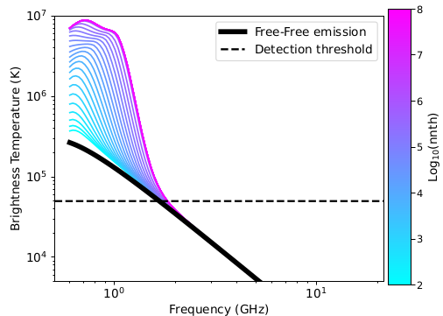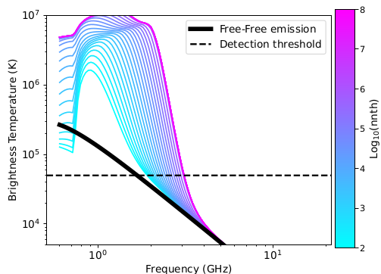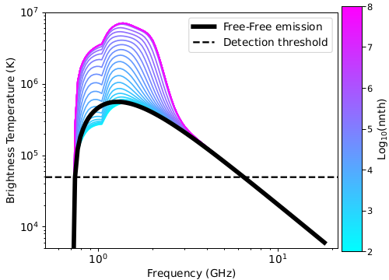
Shows the GS emission due to nonthermal electrons (shown with color) to that of thermal emission (shown in black). The distribution of nonthermal electrons follows a powerlaw with the minimum energy being 6 keV and the powerlaw index of 6. The LOS depth is 3Mm. Temperature is set to 1 MK. Left and middle panel, the thermal density is set to 10^9.2/cm^3. In right panel, the thermal density is set to 10^9.8 /cm^3. For the left panel, magnetic field is set to 100G, whereas for the middle and right panels, the magnetic field is set to 200 G.

In the figure above, we have simulated the predicted brightness temperatures for different typical GS parameters. Magnetic field above coronal bright points typically range from 50-200 G. The nonthermal electron parameters chosen correspond to values estimated in Mondal et al. 2023, Glesener et al. 2020. It is evident that for low thermal density, we can separate out the GS emission from the thermal emission for lower magnetic field. With increase in thermal density, the required magnetic field also increases. The black dashed line shows 0.05 MK, which is the detection threshold which is being targeted.

Image resolution:

Coronal bright points typically have an angular scale of 20”-30” at 1GHz, this science goal demands high fidelity imaging at an angular resolution of 30” (Note that past radio observations have observed larger radio counterparts to CBPs than that at X-rays and EUV, Habbal et al. 1986). However, we note here that at higher frequencies like 4GHz, transient sources as small as 5” have been detected from coronal bright points. We also note that, since for this science goal, the background quiet Sun is not very important, and hence can be subtracted out either in the image place or visibility plane. This would help both in separating out the quiet Sun as well as achieving the high angular resolution.

Estimating number of transients in a single image

Glesener et al. (2020) determined the nonthermal and thermal energy associated with a microflare, using HXR data. It is probably the only measurement available from HXR. The total nonthermal energy deposited was estimated to be 4x10^29 ergs, whereas the corresponding associated thermal energy as measured by AIA was about 4x10^28 ergs. Mondal et al. 2020 found that the ratio of the nonthermal and thermal energy associated with a weak radio transient was approximately 1. Thus based on the available literature, we estimate the ratio between non-thermal and thermal energies can vary between 1-10 . Using a ratio of 1, the flare frequency distribution from Purkhart & Veronica (2022), angular resolution of 15”, and duration of 10 s, we estimate that there are about 2000 transient event above nonthermal energy of 10^24 ergs, over the solar disc. Similarly we estimate that there are about 200 events above an energy of 10^25 ergs every 10s. To relate these number numbers to the expected radio flux, we aim to recover, we use a set of typical coronal parameters. Using a magnetic field of 100G, thermal electron density of 10^9.2/cm^3, nonthermal electron density of 10^6, e_min of 5 keV, emax of 10 MeV, nonthermal electron powerlaw index of 7, we find that the expected brightness temperature is approximately 0.05 MK. Using a PSF size of 10” x 10”, we estimate that the total nonthermal energy dumped over a time interval of 10s is 10^26 ergs. This implies that it is expected there will be about 20-30 events (using the Purkhart & Veronica 2022 scaling relation) every 10s with the total nonthermal energy dumped by those responsible electrons being above 10^26 ergs.

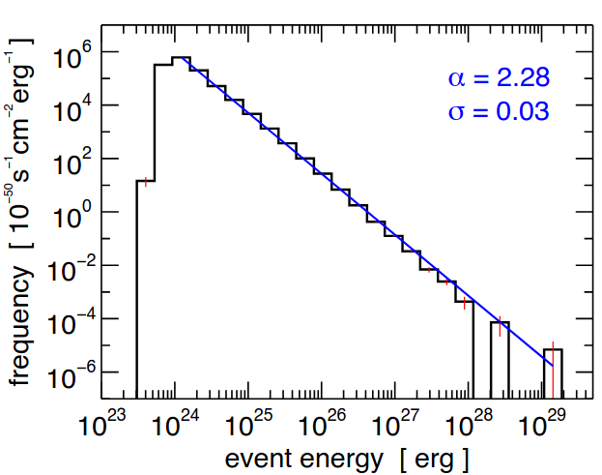

Figure from Purkhart & Veronica (2022)

